**UML Diagrams**

* Use Case: Shows actors (Teacher, Student, Admin, Parent) and actions (Mark Attendance, Enter Grades, View Records, Generate Ranks, Send Alerts, etc.)

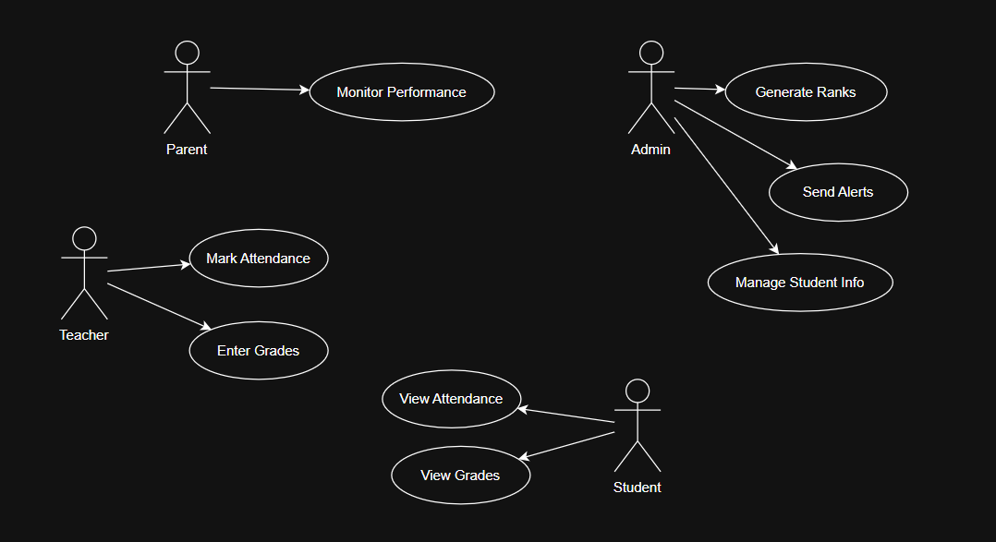

Fig: Use Case Diagram

* Class Diagram: Classes for Student, Teacher, Admin with attributes and methods

Fig: Class Diagram

* Sequence Diagram: Steps for marking attendance

Fig: Sequence Diagram

* Activity Diagram: Steps for generating results

Fig: Activity Diagram